To: CXC Markers and Prospective Applicants
As the Council continues to work toward operations that are more efficient, we introduce you to the Examiners Portal at http://www.cxc.org/markers.
In the past, persons submitted (interest in marking form) each year to confirm interest and availability. The introduction of this new portal will provide among other services:
- A mechanism for persons to continually update personal information such as telephone numbers, mailing addresses, email contact, qualifications, skills and experience;
- Access to marking arrangements including flight and accommodation details; and
- Selection status and marking centre assignment.

The initial process will be to ensure we associate our current database records with the correct individual and subsequently, to have new applicants verified and updated.

The following procedure will be used to accomplish this task.

  - Open the link and click ‘Create a New Account’
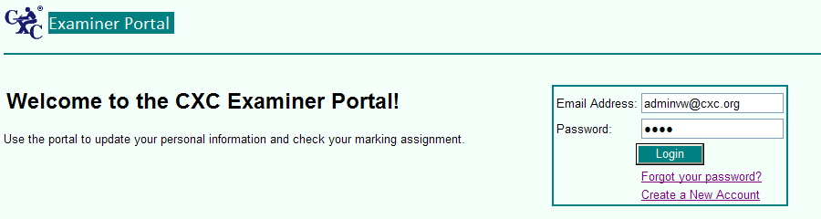
Figure 1

  - Enter a valid email account and a password you intend to use with the Portal, you should not use the same password used to access your email account.

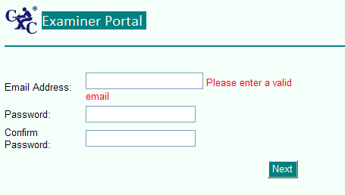
Figure 2
  - If you have marked previously, click Next then enter your name and marking status as applicable otherwise go to 6.

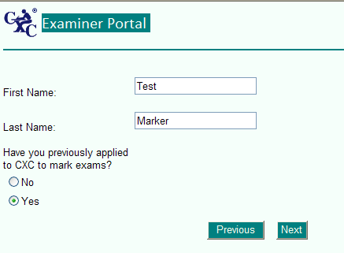
Figure 3
  - If you answered ‘Yes’ to having marked previously, you should enter the details of your previous marking to facilitate our processing your information.

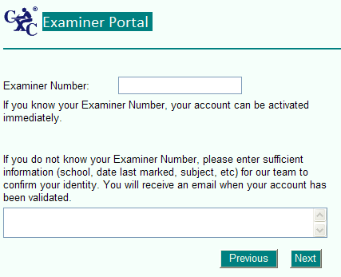
Figure 4

  - The next screen confirms your information and then you click ‘Finish’

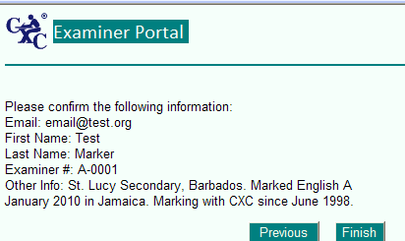
Figure 5
Clicking Finish ends the registration process. You will subsequently be contacted via the email address submitted with additional information.

  - If you have not marked previously, that is a New Applicant, you select ‘No’ and proceed to the next screen.

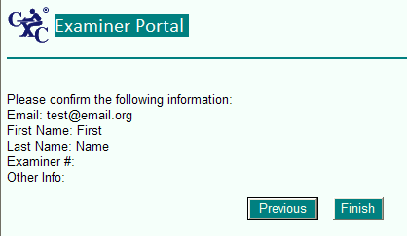
Figure 6
  - Click Finish to take you to the next screen to complete your registration process.

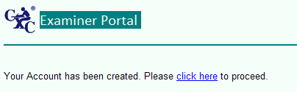
Figure 7

  - You may proceed to entering your details as required.

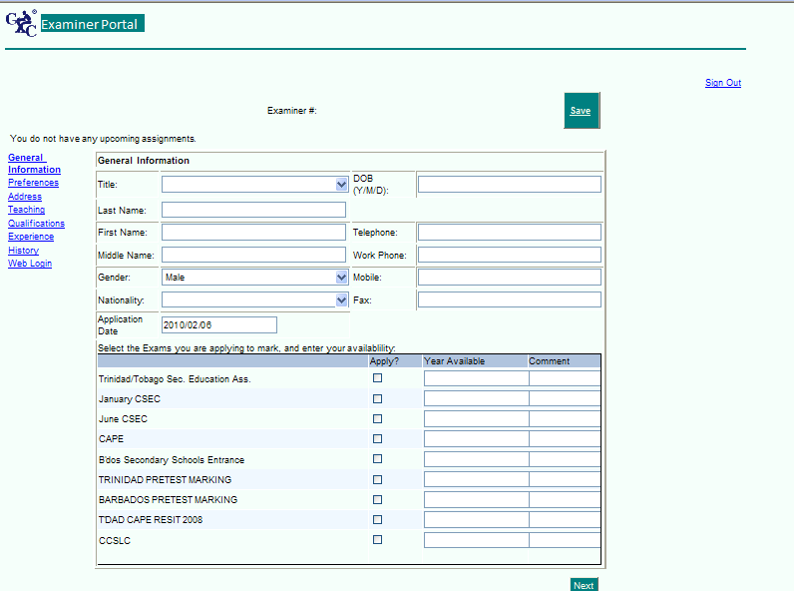
Figure 8

Once you have completed the registration process you will then be able to login to the Portal and complete your updates and check on the status of your application(s).
Note, it is important to use an e-mail account that is active. You should also check that account regularly (at least one per week).
Thank you for your continued interest in working with us during our marking exercises, as we move to the next level.
Best Regards

